Hill Industry Day Location
Weber State University
Shepherd Union Building – Ball Room C
3848 Harrison Blvd.
Ogden, UT 84408

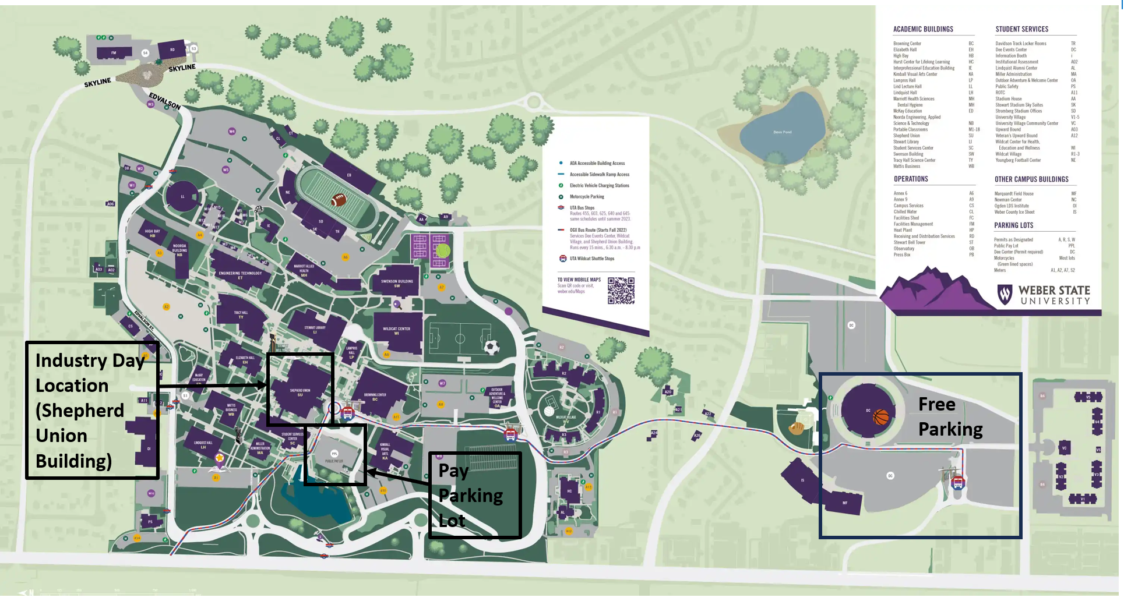

Parking Options and Information
Free Parking
Dee Events Center
4444 Event Center Drive
Ogden, UT 84408

Park in the lot and take the Weber State Shuttle to the Central Campus Stop/Shepherd Union Building.
Shuttles operate from 6:30AM to 8:30PM and leaves every 10 minutes.
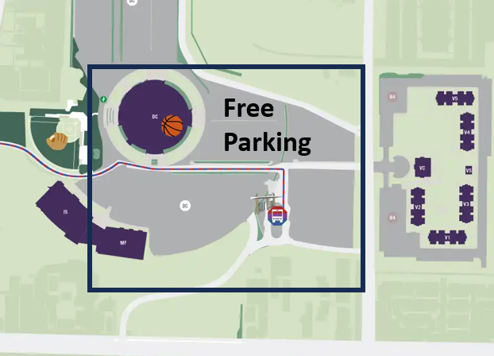

Public Pay Lot Parking
3848 W Harrison Blvd Parking
Ogden, UT 84408

Parking costs $2 for the first hour and $1 for each hour or portion thereof after.
